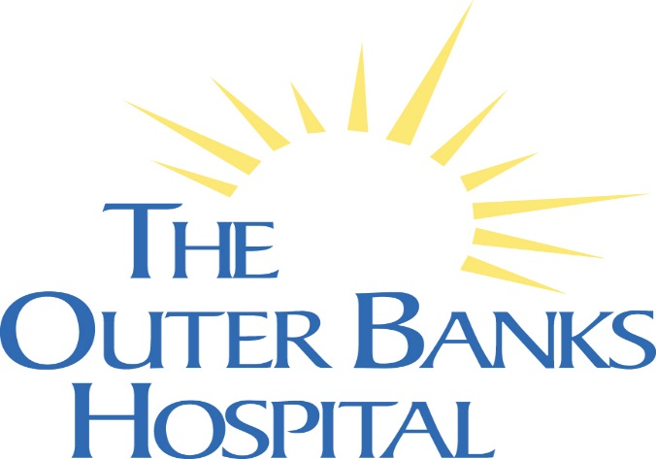

New Team Member Orientation
Congratulations & Welcome to The Outer Banks Hospital.
On behalf of all of the dedicated team members, we are excited for you to be joining our Voyage to Excellence. As a team, we strive to achieve our Mission, Vision, and Values. Working together, we will achieve our vision and goals of being a preferred healthcare provider, employer of choice and national leader in meeting the needs of the Eastern North Carolina communities we serve. Orientation is your first step of understanding our organizational culture, so welcome aboard as we look forward to welcoming you on your first day. The following information is designed to prepare you for orientation:
On day one of Orientation, our Executive Leadership looks forward to having lunch with you, provided by the Hospital. On the second day you will have lunch with Directors and Managers. Light breakfast is served on both days.
Orientation Date & Time: Provided in your Welcome and Onboarding Letter

Location: Port Room
**The Port Room is located on the 2nd floor of the Medical Office Building down the hall across from Human Resources.
HR Contacts: Jan Eanes 252-449-5688 JEanes@theobh.com
Deirdre Buffington 252-449-4545 Deirdre.Buffington@theobh.com
What you need to bring to Orientation:
- Proof of eligibility to work in the United States by bringing two forms of identification such as a driver’s license, social security card, passport or birth certificate. This documentation is required within 3 days of hire. Please review the list of acceptable documents.
What to Wear: On the first day of Orientation you may dress in business casual, this excludes denim. On the second day you should dress as appropriate for your position, i.e. scrubs or business professional.
Due to fluctuations in room temperature in the Port Room, you may want to bring a sweater or light coat.

